Apply to the National Youth Science Camp
The National Youth Science Camp (NYSC) is a three week FREE residential science education program that honors and challenges two graduating high school science students from each state. Scientists from across the nation present lectures and hands-on science seminars and linger to interact informally with student delegates. Delegates are challenged to explore new areas in the biological and physical sciences, art, and music with resident staff members.

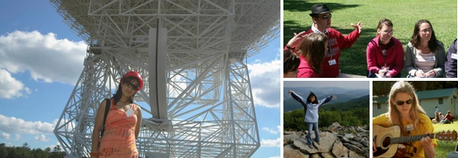

Delegates are given the opportunity to present seminars covering their own areas of interest and research. A visit to Washington D.C. permits delegates to visit some of the nation’s premier scientific, governmental, and cultural facilities.
The NYSC experience includes overnight excursions into the Monongahela National Forest featuring backpacking, rock-climbing, caving, mountain biking, and kayaking opportunities.
Dates: June 14 – July 8, 2017. Delegates MUST be able to attend the entire NYSC program
Location: Facility in the Monongahela National Forest, eastern West Virginia near Bartow
Cost: FREE! All expenses including airfare, housing, meals and program are covered.
Eligibility:
- Must be candidates for high school graduation between July 1, 2016 and June 30, 2017 (seniors);
- Must demonstrate superior academic proficiency, including recognition in mathematics and/or the sciences;
- Must demonstrate an application of leadership abilities and social maturity through involvement in school and community activities;
- Must demonstrate skills and achievements outside the realm of science and outside the realm of academic pursuits; and
- Must demonstrate a curiosity and an eagerness to explore many and varied topics.
Applications and more information are available online at www.nysc.org. Deadline March 1. For state level questions, contact john.c.olson@state.mn.us at the Minnesota Dept. of Education.

